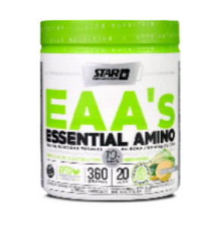  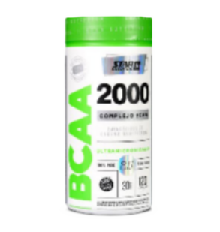  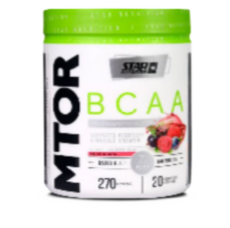  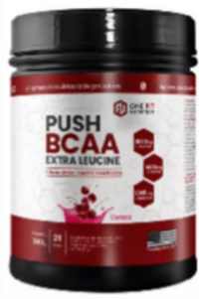  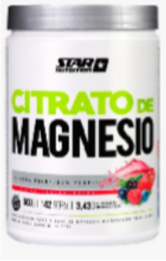  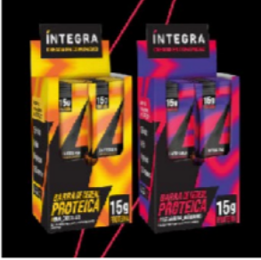  Categoría | Nombre |  |  |  | Sabores | Precio
AMINOÁCIDO | EAA´s Essential Aminos (360 gr) |  |  |  | Limón | $-
BARRITAS PROTEICAS | Integra Barritas proteicas (caja 10u.  15 gr) |  |  |  | -Pasta de maní con arandanos  -Maní con chocolate | $20.000
BCAA | BCAA 2000  (120 caps) |  |  |  | - | $22.000
BCAA | Mtor BCAA (270 gr) |  |  |  | Frutos Rojos | $29.000
BCAA | Push BCAA Extra Leucine (300 gr) |  |  |  | Cereza | $22.000
CITRATO DE MAGNESIO | Citrato de Magnesio (500 gr) |  |  |  | Frutos Rojos | $32.000


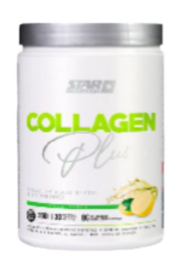  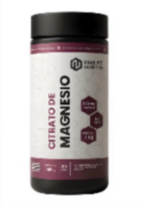  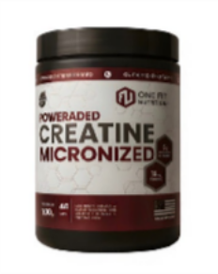  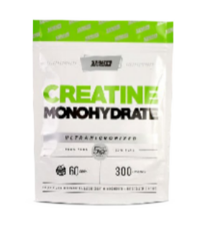  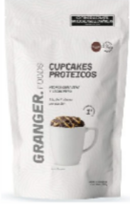  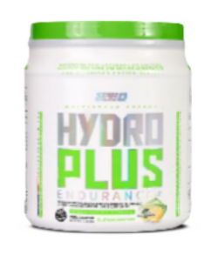  Categoría | Nombre |  |  |  |  |  | Sabores | Precio
CITRATO DE MAGNESIO | Citrato de Magnesio One Fit (150 gr) |  |  |  |  |  | Neutro | $17.000
COLAGENO | Collagen PLUS (360 gr) |  |  |  |  |  | Limón | $26.000
CREATINA | Creatina Monohidrato (300 gr)  Doypack |  |  |  |  |  | - | $30.000
CREATINA | Poweraded Creatine Micronized (200 gr) |  |  |  |  |  | - | $21.000
CUPCAKE PROTEICO | Cupcake Proteico Granger (360 gr) |  |  |  |  |  | Chocolate | $14.000
ENDURANCE | Hydro Plus Endurance |  |  |  |  |  | Limón | $-

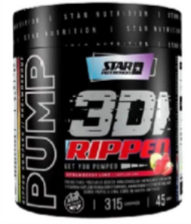  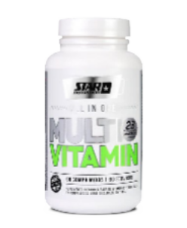  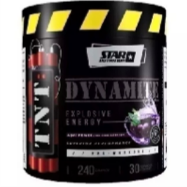  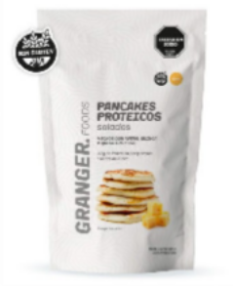  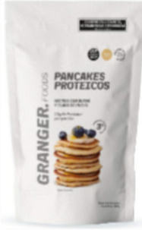  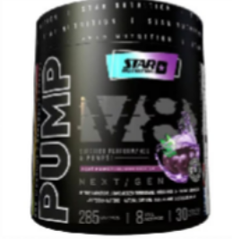  Categoría | Nombre |  |  |  |  |  | Sabores | Precio
MULTIVITA- MINICO | All in One Multivitamin (60 caps) |  |  |  |  |  | - | $24.000
 | Granger Foods
PANCAKES PROTEICOS | Pancakes  Proteicos Salados |  |  |  |  |  | Queso | $14.000
 | Granger Foods
PANCAKES PROTEICOS | Pancakes  Proteicos Dulces |  |  |  |  |  | Chocolate Vainilla | $14.000
PRE- ENTRENO | Pump 3D RIPPED (315 GR) |  |  |  |  |  | Limón Frutilla y Limón | $40.000
PRE- ENTRENO | TNT  Dynamite (240 gr) |  |  |  |  |  | Blue Raz Acaí Power | $28.000
PRE- ENTRENO | Pump V8 (285 gr) |  |  |  |  |  | Acaí | $-

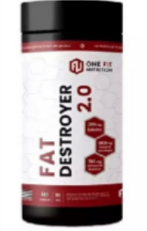  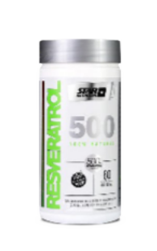  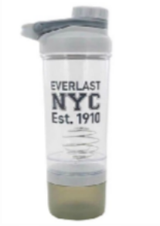  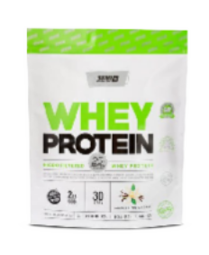  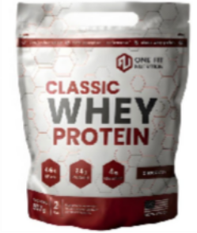  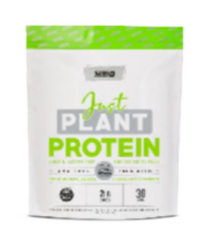  Categoría | Nombre |  |  |  |  |  |  | Sabores | Precio
PROTEINA | Whey Protein 2 LB DoyPack |  |  |  |  |  |  | Chocolate Vainilla Frutilla Coockies | $45.000
PROTEINA | Classic Whey Protein 2 LB One Fit |  |  |  |  |  |  | Chocolate Vainilla | $31.000
PROTEINA | Just Plant Protein 2 LB |  |  |  |  |  |  | Neutro | $45.000
QUEMADOR | Fat Distroyer 2.0  One Fit (90  caps) |  |  |  |  |  |  | - | $19000
REVERASTROL | Resveratrol 500 (60 caps) |  |  |  |  |  |  | - | $-
SHAKER | SHAKER EVERLAST |  |  |  |  |  |  | Gris Celeste Rosa | $17.000

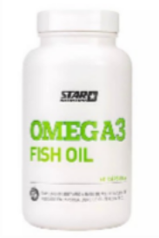
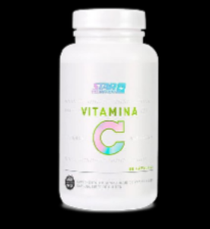
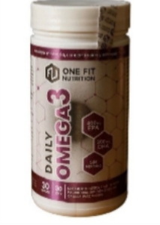
Categoría
Precio
Sabores
Nombre

VITAMINA C

$12.000
-

Vitamina C (60 caps)

OMEGA 3

$32.000
-

Omega3 Fish Oil(60ca ps)

OMEGA 3

$26.000
-

Daily Omega 3
(30 caps)

